Ideation Phase Empathize & Discover

|  |  |
| --- | --- |
| Date | 03 October 2023 |
| Team ID | Team-591577 |
| Project Name | Potato Disease Classification |
| Maximum Marks | 4 Marks |

# Empathy Map Canvas:

An empathy map is a simple, easy-to-digest visual that captures knowledge about a user’s

behaviors and attitudes.

It is a useful tool to helps teams better understand their users.

Creating an effective solution requires understanding the true problem and the person who is experiencing it. The exercise of creating the map helps participants consider things from the user’s perspective along with his or her goals and challenges.

# Example:

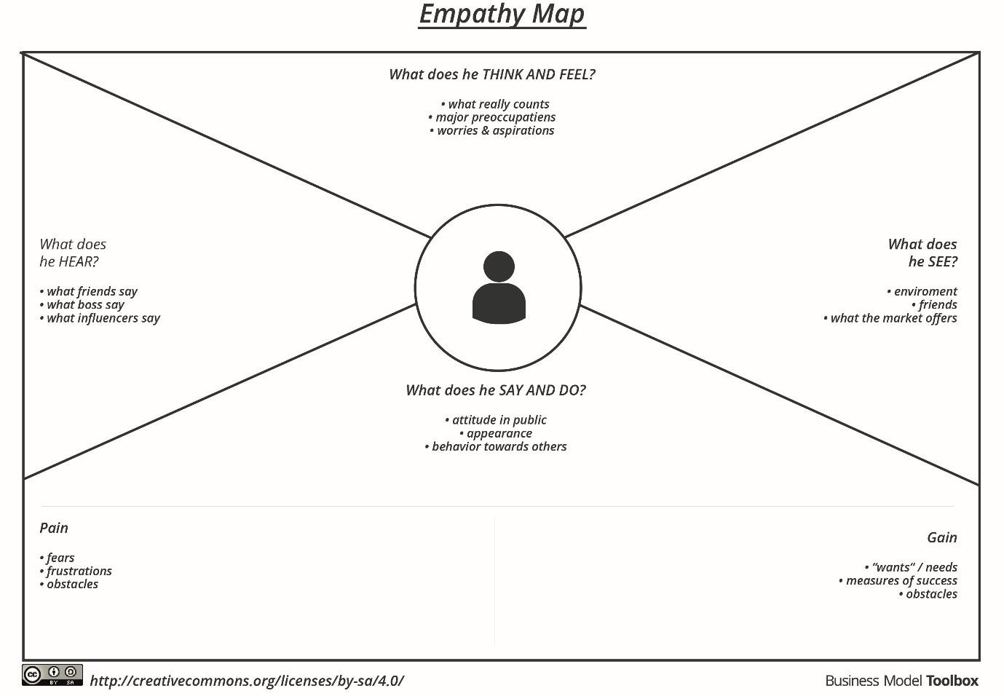

Reference: <https://www.mural.co/templates/empathy-map-canvas>

### **Example: Potato Disease Classification**

What the farmer says

* "I'm worried about my potato plants. They don't look healthy."
* "I'm afraid I might lose my entire crop."
* "I don't know what to do to save my plants."
* "I wish there was a way to know for sure what's wrong with my plants."
* "I want to be able to take action to save my plants as soon as possible."

What the farmer does

* Takes pictures of their potato plants
* Researches potato diseases online
* Asks other farmers for advice
* Tries different treatments
* Gives up and destroys their plants

What the farmer thinks

* I'm going to lose my entire crop.
* I don't know how I'm going to feed my family.
* I'm never going to be able to grow potatoes again.
* I'm all alone.
* There's no hope.

What the farmer feels

* Worried
* Stressed
* Frustrated
* Helpless
* Hopeless

Pain

* Losing their potato crop
* Not knowing what to do to save their plants
* Feeling helpless and hopeless

Gain

* Saving their potato crop
* Learning how to identify and treat potato diseases
* Feeling empowered and optimistic